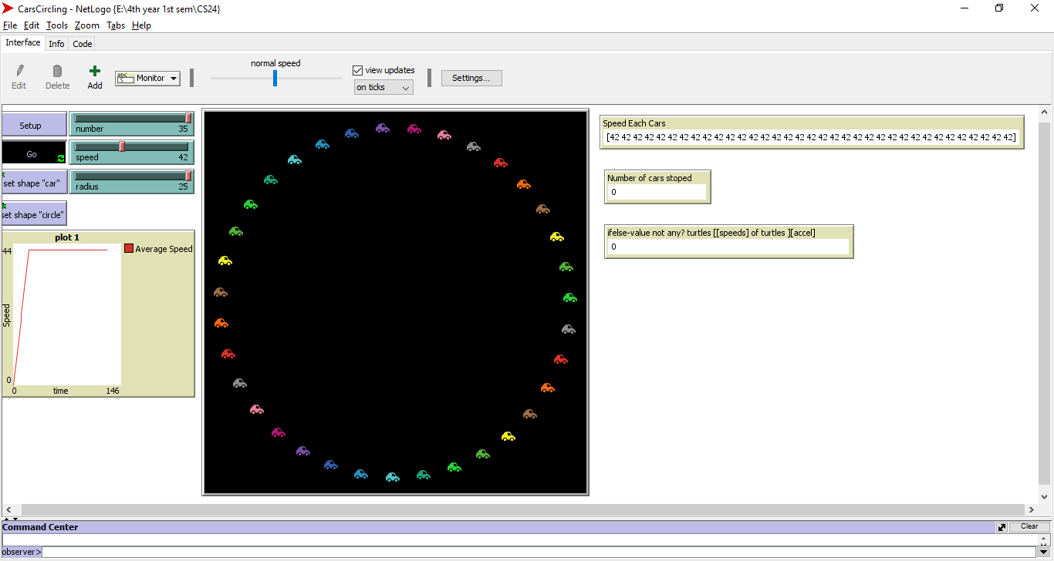

We can see that the cars are at their limit of number but they are still going at a they their fastest speed (set up by the user) because they have enough distance to move.

Average speed of each turtles

The turtles will also stop moving if the cursor is hovered over causing more traffic or most commonly as the phantom intersection. In which the other cars will cause another phantom intersection 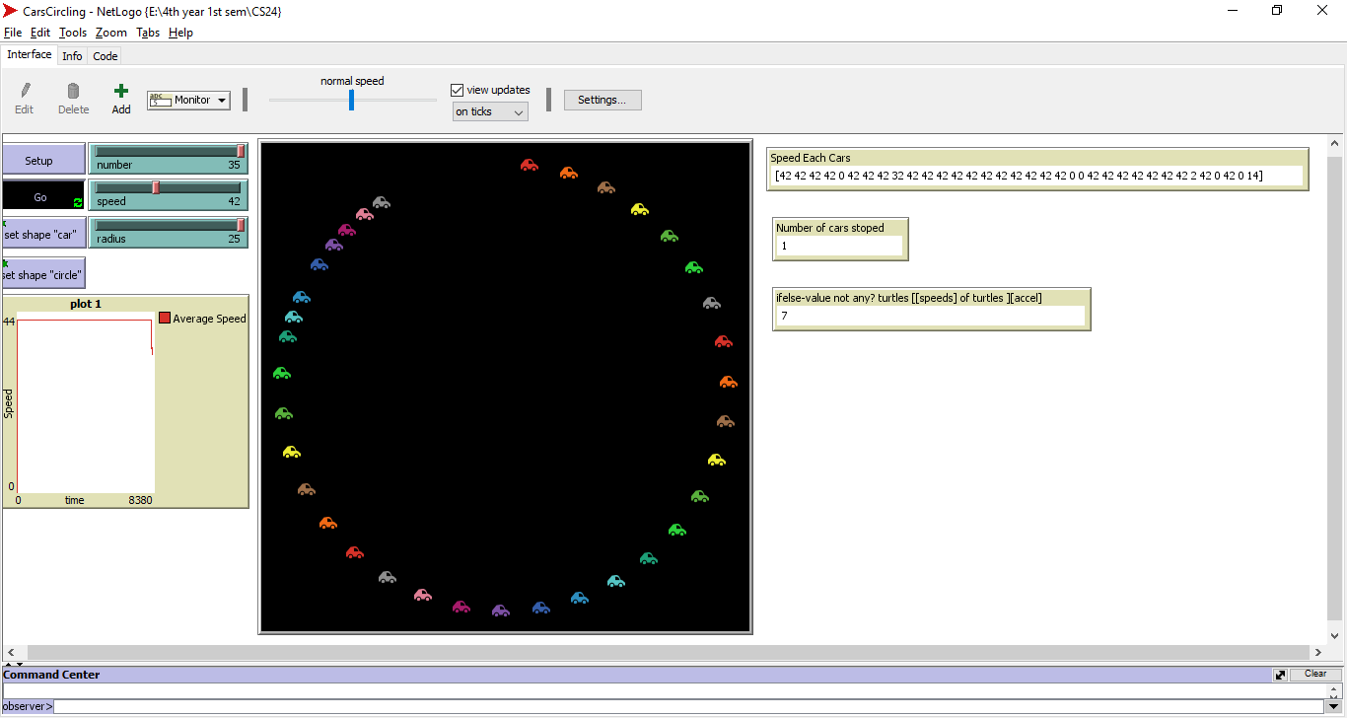

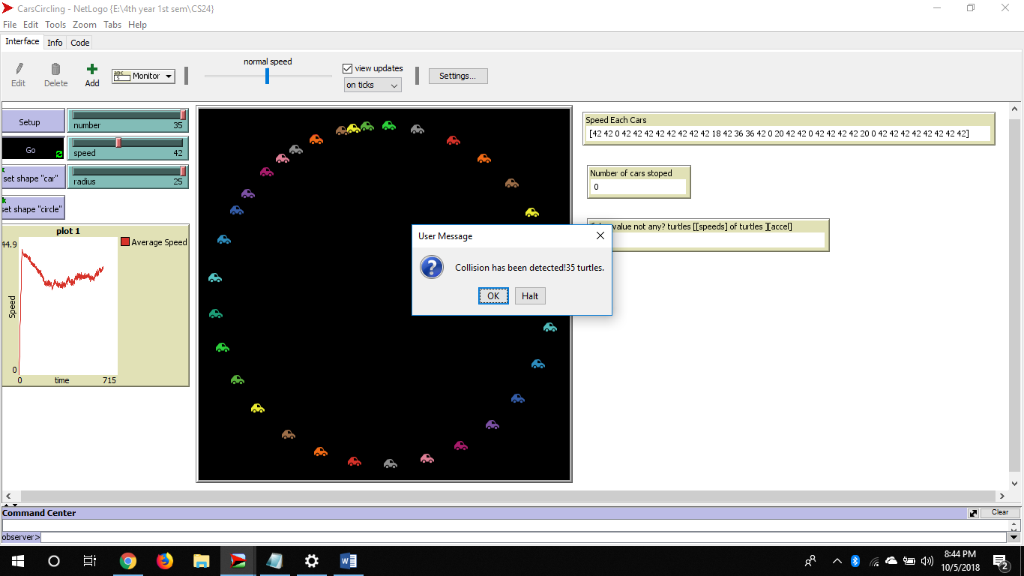

This time the cars had a collision

Which dropped the average speed. Radius is the amount or how big the gap of the cars are